# Part A

Group : **L19-G4.**

Members : (aguo4791, 520644847) (rcha0546, 520392823) ({slpa9090},{500545654}) (npai5889,520617829)

Note to markers: We wish for this report to be individually marked. Thank you!

## 1. Introduction

This report aims to analyse how worldwide maternal mortality ratio is impacted by the level of the following healthcare personnels present within a population:

1. Physicians
2. Nurses
3. Pharmacists.

These figures are then compared alongside how many of these key healthcare personnel are actually present at the time of birth. In general key stakeholders that will be of interest include healthcare institutions and other organisations associated with obstetrician organisations.

This dataset comes from the UN, with additional cleaning conducted by Alan Fekete. As such this is secondary pre-processed data, however it comes from a reliable organisation, improving the accuracy of the data figures.

| **Name** | **Description** | **Unit** |
| --- | --- | --- |
| Proportion of births attended by skilled health personnel (%) | Treated as Independent Variable. $\frac{Number of births attended by healthcare workers}{Live Births per country}×100$ | (%) |
| Maternal mortality ratio | Treated as Independent Variable | % |
| Health worker density by type of  occupation (per 10,000 population)::  Physician | Treated as Independent Variable | % |
| Health worker density by type of  occupation (per 10,000 population)::  Nursemidwife | Treated as Independent Variable | % |
| Health worker density by type of  occupation (per 10,000 population)::  Pharmacist | Treated as Independent Variable | % |
| Region | Countries were separated into geographical regions including Europe, Asia, Africa, Oceania, and Americas | N/A |
| Year | The above data was analysed for 4 discrete years: 2000, 2005, 2010, 2015 | Number |

## 2. Dataset Description

The following section details the identifier in the dataset chosen and the members responsible for handling the data analysis of this feature.

### 2.1 Health Worker Density, Pharmacist vs MMR

520644847 was responsible for the completion of this section.

#### 2.1.1 Dataset Description

The dataset chosen was gathered from the United Nations Statistics Division (UNSD), and entails health related fields for different countries in varying years. The data ‘SDG_goal3_clean.csv’ came precleaned in a .csv format and as such no cleaning was performed. It’s structured in a long schema, where the country and year are the entities. This section primarily focuses on the relationship between ‘Pharmacist worker density per 10,000 population’ and ‘Maternal mortality ratio’. An excerpt can be seen below :

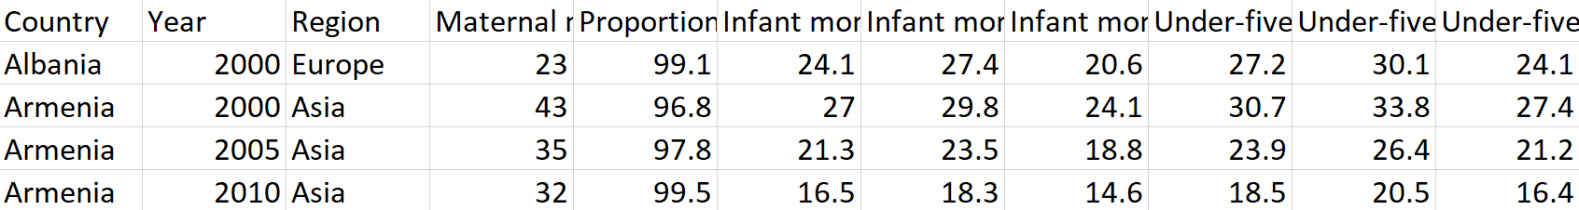

*Figure 1 - Excerpt from dataset, ‘SDG_goal3_clean.csv’*

#### 2.1.2 Grouped Aggregate Summary

The grouped-aggregate summaries obtained for this section groups all 164 observations in the dataset and was completed in Python. For the first summary, Pharmacist worker density (per 10,000 population) was averaged and binned by continent and year. The code used to produce this can be found in Appendix A.1.

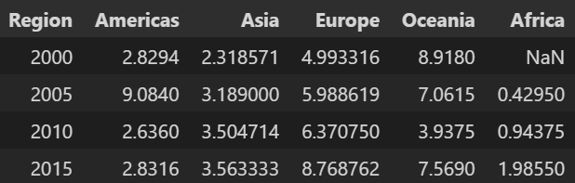

*Figure 2 - Summary of aggregated Pharmacist worker density by region and year*

For the second summary obtained, much the same was done for Maternal mortality ratio, which was also averaged and binned by continent and year. The code used to produce this can be found in Appendix A.2.

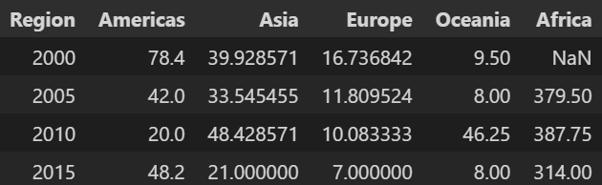

*Figure 3 - Summary of aggregated Maternal mortality ratio by region and year*

#### 2.1.3 Charts Produced

The two grouped aggregate summaries were plotted side by side as bar charts in Python, using the data frames created in section 2.1.1. The charts themselves can be seen in the figure below.

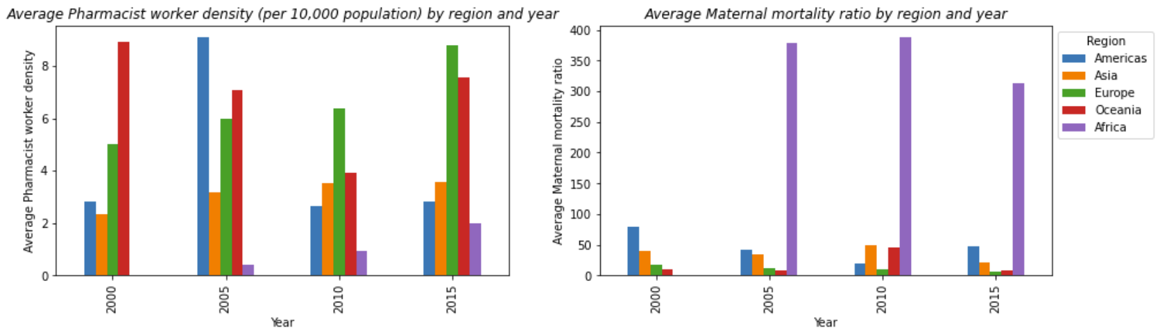

*Figure 4 - Bar plots of the two grouped aggregate summaries produced*

The plots were produced using the ‘matplotlib.pyplot’ library, where a subplot was created first using the ‘.subplots()’ function. Then using each grouped aggregate summary in the form of a pandas dataframe, it was plotted on each subplot using ‘.plot.bar()’. For each subplot, the title, xlabel and ylabel were all specified, and only one legend was kept, as they were the same. Lastly, the configuration of the subplots were changed using ‘.subplots_adjust()’ so that the graphs/text did not overlap. The code to produce this can be found in Appendix A.3

Overall, each barplot does its intended job effectively. It’s simple to understand with not a lot of information overload. It shows the grouped aggregates in a comprehensible form with an appropriate legend, and correctly labelled title/xlabels/ylabels. One thing that could be said however, is in the second chart the readability may be compromised by the fact that Africa has relatively high average maternal mortality ratios.

The other chart plotted was a scatterplot showing the relationship between Pharmacist worker density and Maternal mortality ratio, to see if there was a correlation between the two. The charts created and code used can be seen in the figures below :

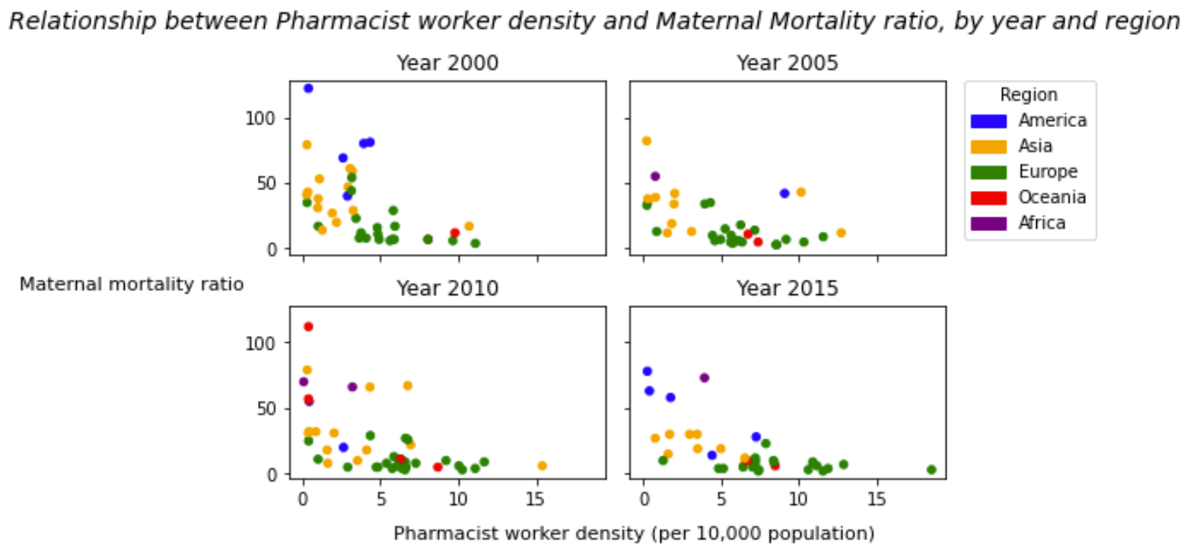

*Figure 5 - Plots of Pharmacist worker density against Maternal mortality ratio for each year*

The code used to produce the scatterplots was done in Python and made use of the ‘matplotlib.pyplot’ library. The original data frame read in was first altered to colour code the regions for easier plotting, and renamed a column to tidy it up. Then a subplot was created where a for loop was used to plot Pharmacist worker density against Maternal mortality ratio for four different years. They were also appropriately titled and had their axes labels removed. The figure was then automatically structured so that no overlap existed using ‘.tight_layout()’, the axes labels were manually entered using ‘.text()’ and the title was created using ‘.suptitle()’. Then using the ‘matplotlib.patches’ library, a custom legend was created and added to the side of the subplots. The code described here can be found in Appendix A.4.

The subplots created avoided overcrowding the plot with information by splitting the data into years and showing it on 4 different plots. The plots also allow us to see the general trend of an inverse correlation between Pharmacist worker density and Maternal mortality ratio. Additionally, by plotting it by year, this makes the data look interesting year by year and allows the readers to compare different parts of the data at multiple levels of detail. However, a limitation of these plots may be that the inverse correlation trend could be better visualised via the incorporation of a line of best fit.

### 2.2 Dataset 2 – Physician density per 10k vs MMR

#### 2.2.1 Dataset Description

This data analysis is with regards to physician density per 10000 people and its effect on MMR. The data was pre cleaned in a .csv format. The dataset is formatted in long format and the columns health worker density by type Physician and Maternal mortality ratio were a part of it. The data was organised by year and region. The years are split up from 2000, 2005, 2010, 2015 while the regions are Europe, Oceania, Africa, Asia and North America

#### 2.2.2 Grouped Aggregate Summary

Averages of Physician density and MMR by Region

Code used to produce these averages

Fig.1 Code for producing Maternal mortality ratio averages



Fig. 2 Code for producing Physician Density Averages



Fig 3. Table of Averages for MMR and Physician Density Grouped by Region

| **Region** | **Maternal mortality ratio** | **Physician density** |
| --- | --- | --- |
| **Africa** | 367.250000 | 7.810000 |
| **Americas** | 57.916667 | 17.778917 |
| **Asia** | 37.395833 | 23.200854 |
| **Europe** | 11.235294 | 34.785024 |
| **Oceania** | 23.600000 | 23.040600 |

#### 2.2.3 Charts Produced

Fig 4. Scatter plots by region

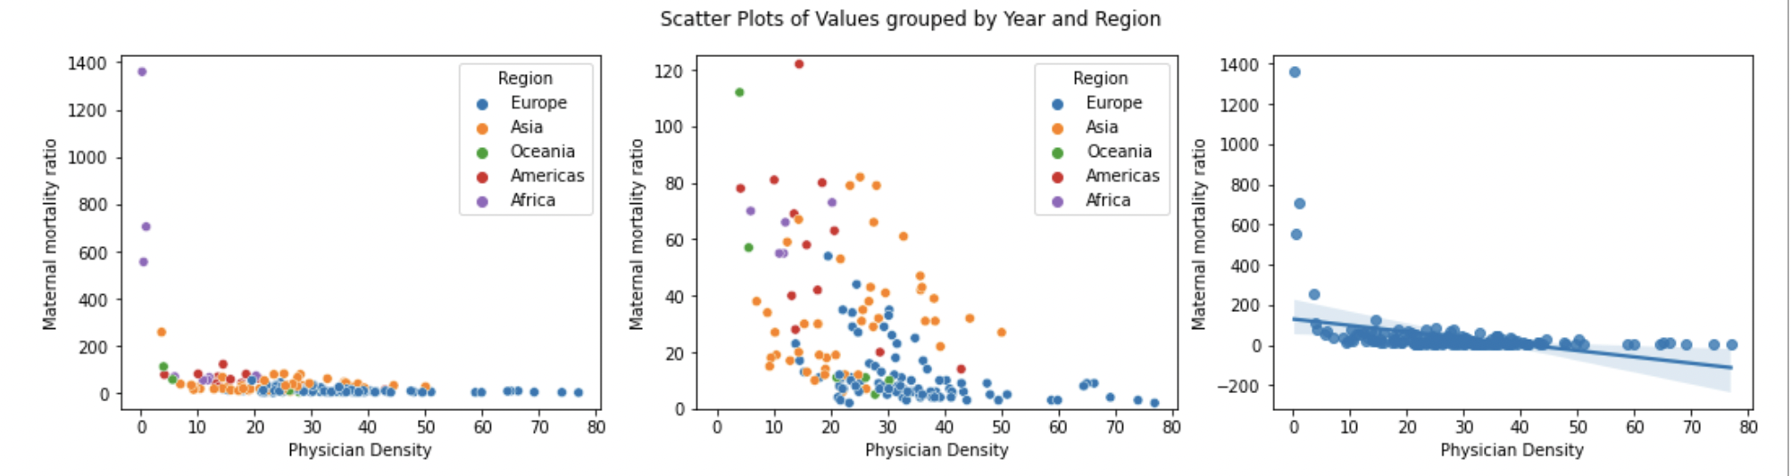

Fig 5. Code used to produce Fig.4.

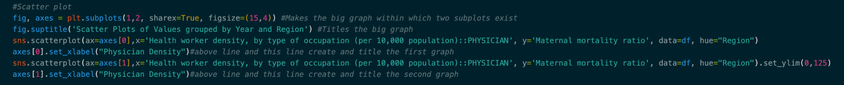

Evaluation:

These 3 charts together represent the relationship between Maternal Mortality Ratio and Physician density. The first chart is the raw data grouped by region, while the second chart is the same except with a y limit of 120. This decision was made due to a majority of the data being concentrated under 120, and as such hard to interpret. As such the second chart supplements the first chart, making it easier to read. The third chart is a linear regression plot, it shows the overall trend in and supplements the first chart..

Each plot makes good use of visual attributes and supplements the first plot effecitvely. One issue however is that chart readability is compromised to a minor extent. This is as readers need to infer that all three charts are related to each other, and that charts 2 and 3 supplement chart one.

Fig 6.Histogram of Physician density per 10000 population

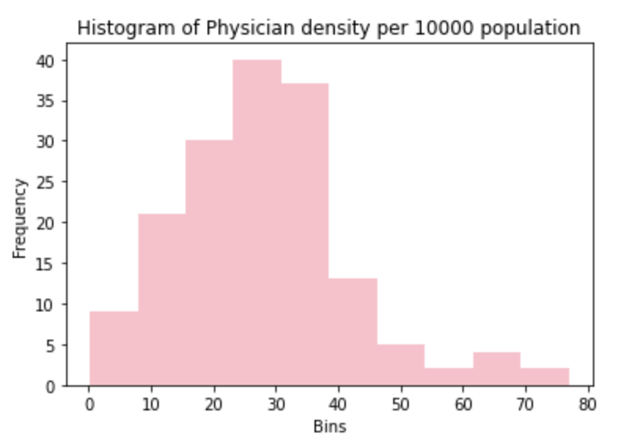

Fig 7. The code that was used to produce figure 6



Evaluation:

This histogram does an effective job of displaying the binned quantitative data. It simply takes one column and makes a histogram out of that column. This graph is effective because it is labelled correctly and is easy to understand. One thing however is that a user must have context of the issue, otherwise this chart cannot be interpreted.

Fig 8.Scatter plot of values grouped by values and region

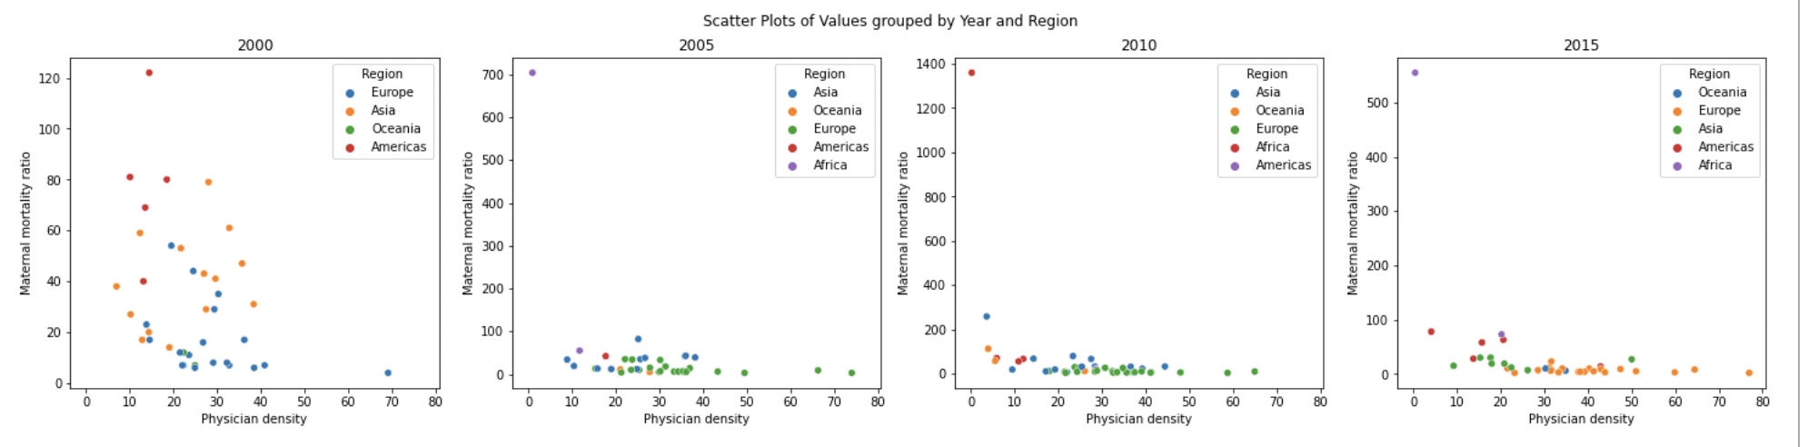Fig.9 The code that was used to produce Fig. 8

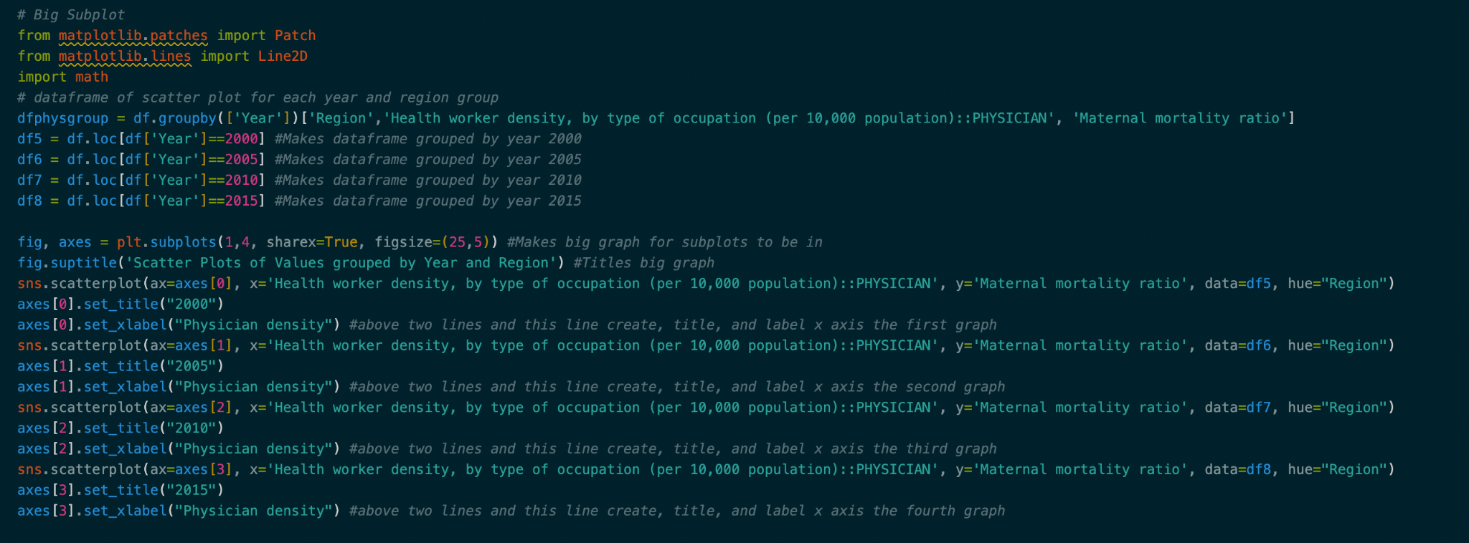

Evaluation:

This set of charts although large does its job effectively. Each chart is titled with the year that it uses to group the data by, while each chart individually then represents the data grouped by region. As such if someone were interested in the differences across years they would be able to interpret it easily.

The charts use visual encoding with each region having a different colour assigned to it. The fact that each chart is titled and split by year makes it easier to isolate data for a viewer.

A limitation however, is that each chart has different colours for different regions. As such users have to take extra time to interpret the chart. An example would be blue represents European data in the chart for 2000, however, in the chart for 2005 blue represents Asia. This makes it more difficult to interpret the charts and compare data directly.

### 2.3 Health Worker Density, Nursemidwife vs MMR (520617829)

#### 2.3.1 Dataset Description

This part of the data analyses the relationship between maternal mortality ratio and the density of nurses and midwives (for every 10,000 of population). This was done to see if the availability of nurses and midwives reduce the MMR and improves maternal healthcare as nurses and midwives reduce stress and increase assistance/sanitation during childbirth, which is why exploring the data is interesting.

The columns used in the analysis were from a precleaned dataset structured in long format. No data cleaning was required.The columns analysed were maternal mortality ratio,region,year and health worker density(nurse or midwife):

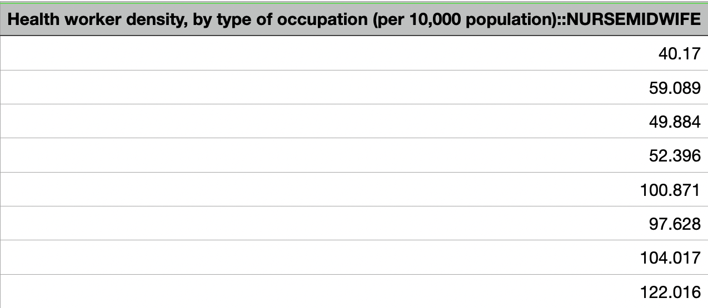 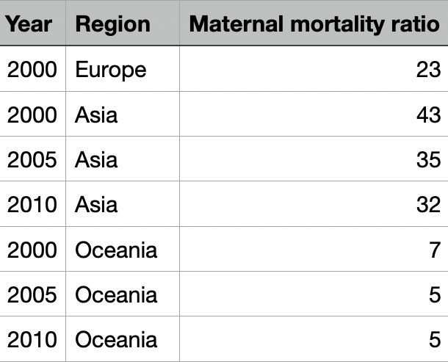

*Figure 1 and 2: Excerpt from dataset:SDG_goal3_clean*

#### 2.3.2 Grouped Aggregate Summary

1)The original dataset was grouped by region and then the sum of maternal mortality ratio was taken to produce the first grouped aggregate summary.

2)The original dataset was grouped by region and then the sum of nurse or midwife density was taken to produce the second grouped aggregate summary.The code used to produce the above two tables is as follows:

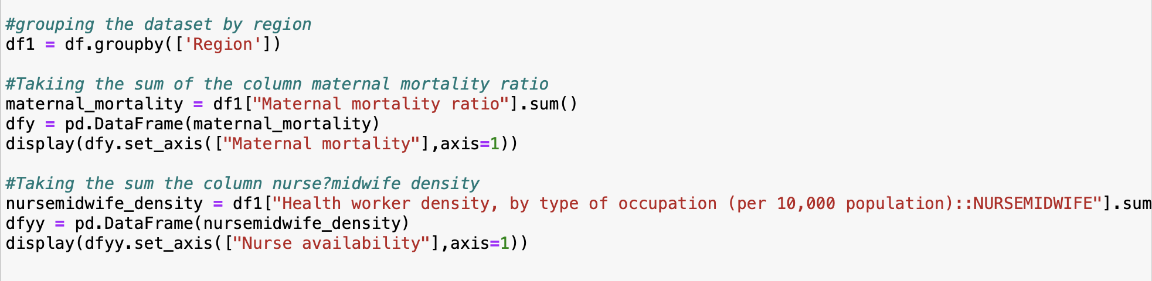

*Figure 3: Code used to produce grouped summaries*

| *a.) Figure 4: Sum of Maternal mortality ratio for a region* | *b.) Sum of Nurse/midwife density for a region* |
| --- | --- |

**Summary on grouped aggregates produced**:

Summary on Table 1:

The table gives the sum of values of “Maternal mortality ratio” grouped by “Region”. The maternal mortality ratio is the highest in Africa followed by Asia,Europe,Americas and Oceania. This table was made to get a good idea of the total maternal mortality ratio in each region and reach stronger conclusions. This table will be more useful when read simultaneously with Table 2.

Summary on Table 2:

The table gives the sum of values of “Health worker density, by type of occupation (per 10,000 population)::NURSEMIDWIFE” grouped by “Region”.The maternal mortality ratio is the lowest in Africa followed by the Americas,Ocenia,Asia and Europe.This table was made to get a good idea of the total Nurse/midwife in each region and reach stronger conclusions.The relationship between the sums of these individual columns (see table 1)does not seem to be inversely related as one might expect it be, this could be because the units aren’t the same and the population density in these regions differ which becomes a confounder in reaching any substantial conclusion.

#### 2.3.3 Charts Produced

Chart 1:

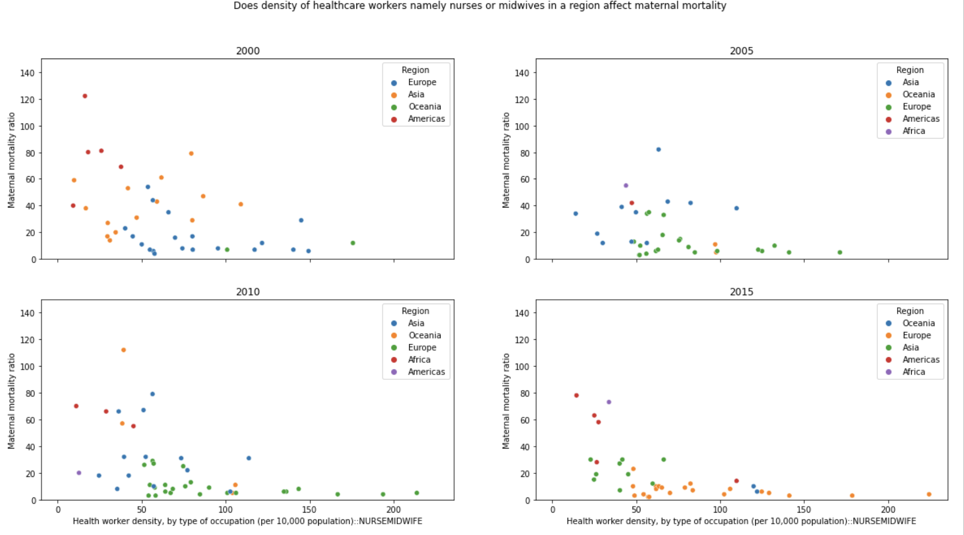

*Figure 5: Scatterplot showing the relationship between maternal mortality ratio and density of nurses and midwives for region and years*

*Figure 6: Code used to produce the above charts: For full code please refer to appendix B.3*

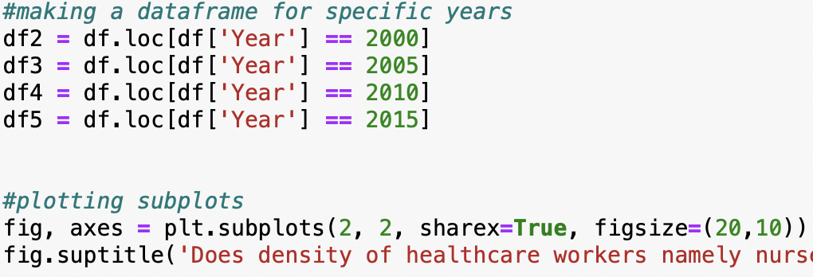

*Figure 8. Chart without outliers* 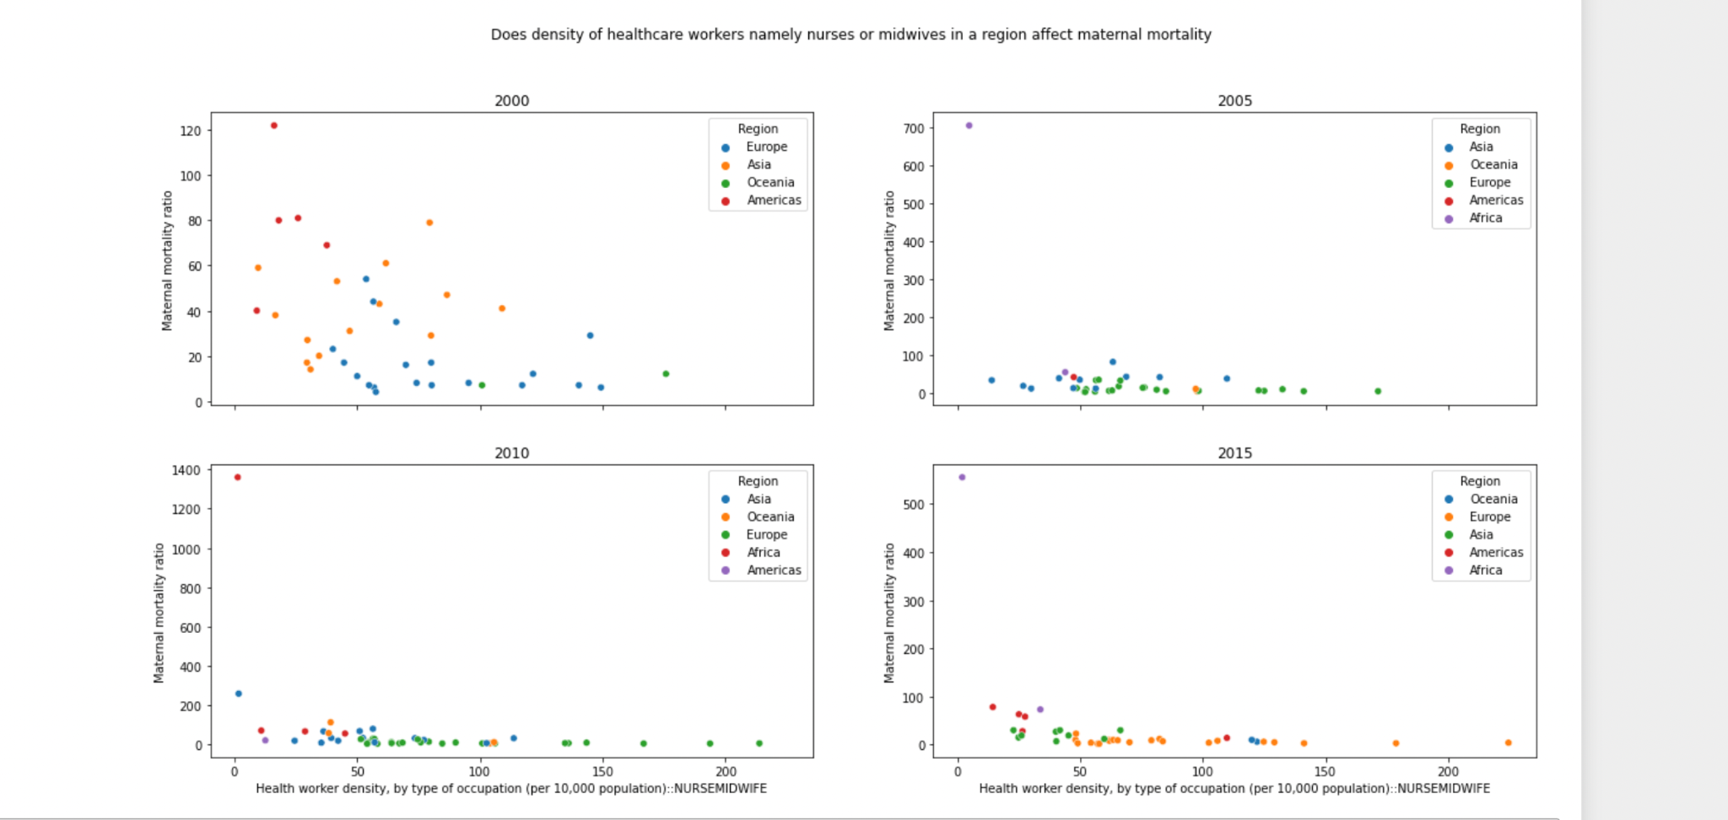

**Evaluation:**

In chart 1 the relationship between availability of health workers namely nurses or midwives and maternal mortality ratio in a region for different years was explored.The y-axis represents “Maternal mortality ratio”.The x-axis represents “Health worker density, by type of occupation (per 10,000 population)::NURSEMIDWIFE” .

The different colours represent different values of the column “Region”.A scatter plot was used to show the relationship between two different quantitative attributes(x and y axis ) according to region which is a nominal attribute for each year in the dataset.The subplots are produced for each year.Scatterplots are difficult to interpret; this does become a hindrance in readability .

This plot was used because it gets easier to get an estimate of the values of different columns at a glance.The outliers in the dataset were taken out to produce the final chart so that the relationship is clearer to the reader.There seems to be a weak negative correlation between the availability of health workers : nurses/midwives and maternal mortality ratio for a region in a year .This correlation of course isn’t uniform for each region but gives us a good understanding of the data.

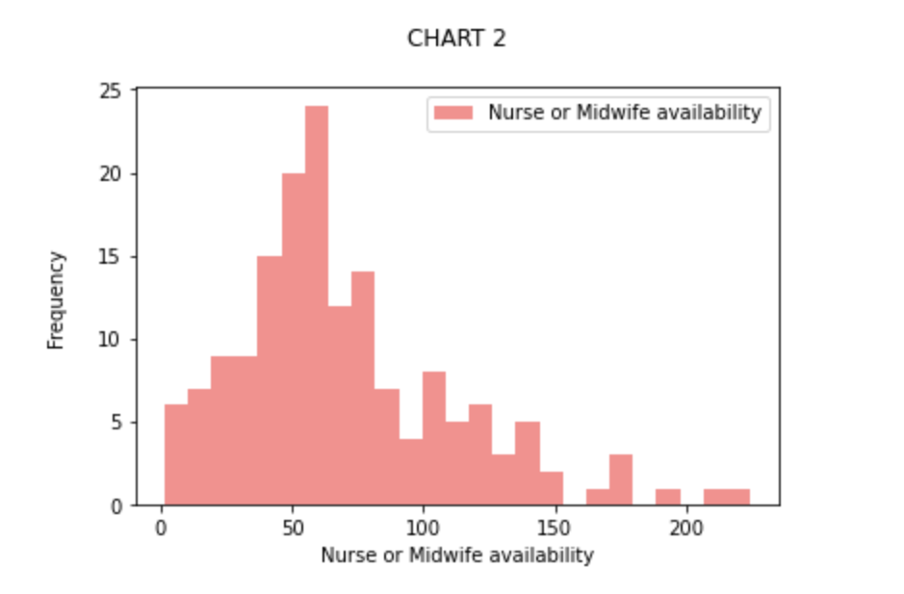

*Figure 9: Histogram showing the frequency of maternal mortality*

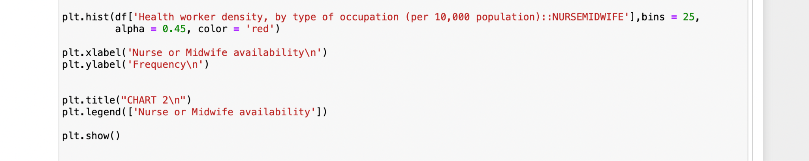

*Figure 10: Code used to produce histogram*

**Evaluation**:

The x-axis represents maternal mortality ratioThe y-axis represents frequencyThe bin width was set to 25 because the values in maternal mortality ratio, range from an estimated 10 to an estimated 225.The colour was set to red and the transparency was set to 0.45 to make the chart more aesthetically appealing to the reader.The chart effectively gives us an understanding of the maternal mortality ratio and its different value ranges.

Limitations: It is not possible to interpret exact values for the column in the dataset.

### 2.4 Proportion of births attended by skilled health personnel (%)

#### 2.4.1 Dataset Description (500545654)

This section of the data aims to analyse how maternal mortality ratio is impacted by the proportion of births attend by skilled health personnel (%) (PBH). This figure is important as the presence of a skilled health care provider at the time of birth indicates the availability of lifesaving intervention for both women and newborns.

Skilled health personnel mainly include doctors, nurses/midwives but also other professional healthcare providers. Specific stakeholders who may be interested in this data include those involved in the hiring and rostering of healthcare workers in the obstetrician unit of hospitals and other healthcare organisations.

**About the dataset:** As stated above, the column was extracted from a larger dataframe titled that came in a long format, which listed the geographical regions and the years. This was analysed alongside the report’s main dependent variable (maternal mortality ratio).

| **Name** | **Description** | **Unit** |
| --- | --- | --- |
| Proportion of births attend by skilled health personnel (%) | Treated as Independent Variable. $\frac{Number of births attended by healthcare workers}{Live Births per country}×100.$ | (%) |
| Region | Countries were separated into geographical regions including Europe, Asia, Africa, Oceania, and Americas | N/A |
| Year | The above data was analysed for 4 discrete years: 2000, 2005, 2010, 2015 | Number |

Table 1: Shows the schema of the columns used to produce the relevant dataset.

#### 2.4.2 Grouped Aggregate Summary (S1, S2, S3)

Three main summaries were created.

**Summary 1**

Table created to understand the median and mean values of the PBH(%), grouped by year year. 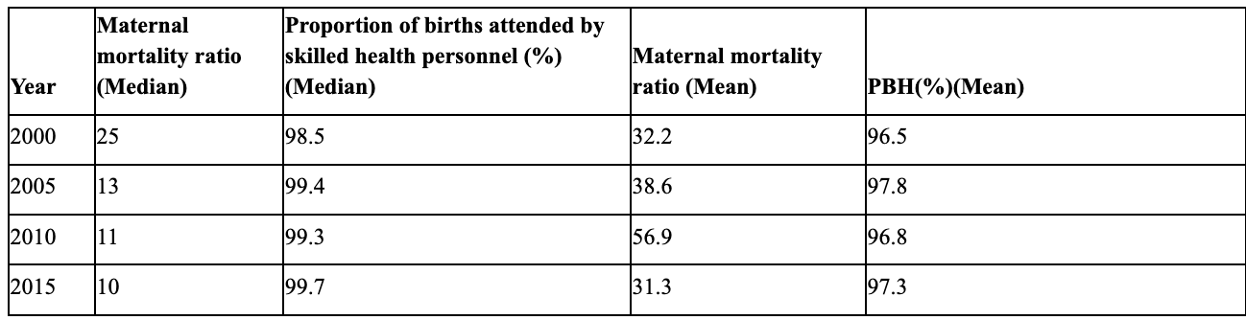

*Table 2: Mean and Median, grouped by ‘Year’ for MMR and PBH(%) given to 1.dpTable 3.*

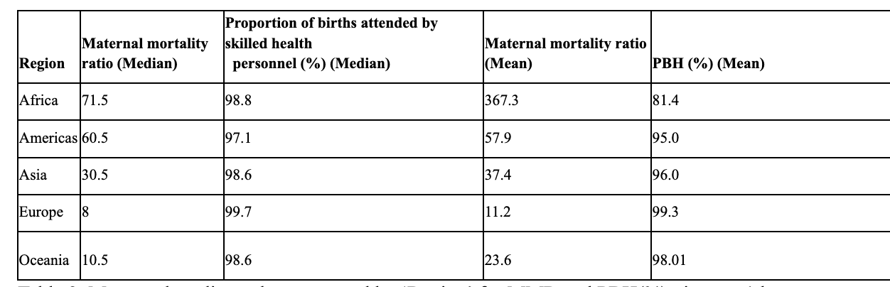

*Table 3. Mean and median values, grouped by ‘Region’ for MMR and PBH(%) given to 1dp*

***Overall aggregate summary 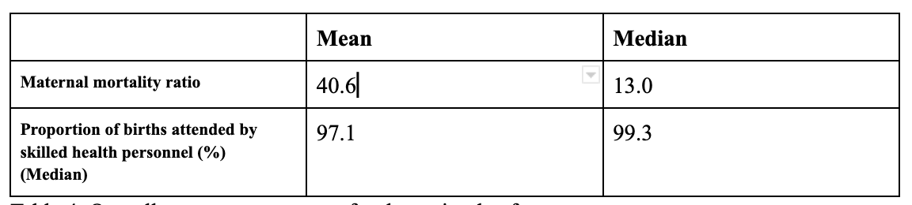****Table 4. Overall aggregate summary for the entire dataframe*

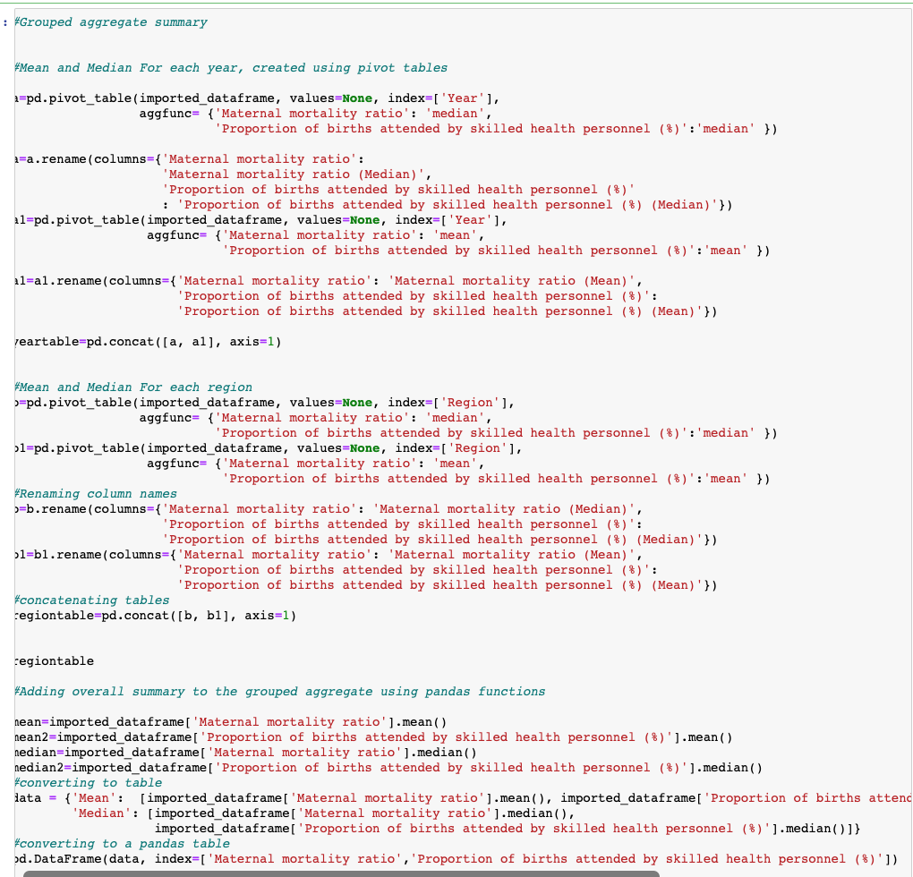

*Figure 1. Snapshot of Code used to produce grouped aggregate and overall aggregate summaries. Refer to Appendix C 4.1 for overall code. For outputs of tables see Appendix C 4.2*

**Code used to produce grouped aggregate summary :**Pivot table and the median/ mean values were calculated used ‘aggfunction, grouped using the function “index”. (2) Column names were renamed. (3). Mean and Median tables were concatenated. Overall Aggregate summary was calculated using pandas’ inbuilt median/ mean function

**Summary 2**

Summary table 2 has binned the two main columns of interest using the pd.cut function and their categorical counts were calculated using the ‘Cross-Tabulate’ function in Pandas. The MHR and PBH(%) columns are continuous variables and they were made discrete/ binned using World Health Organisation (WHO, 2022) criteria: MMR was categorised as (<25, [25-50), [50-100),[100-150), [150-500),[500-1360), represented as Very Low, Medium Low, Low, High, Very High, Extremely High. PBH(%) was categorised using presets provided by UNICEF: [0-65), [65-90), [90-94.375), [94.375-98.75), [98.75-100], as "Very poor attedance", "Poor attendance", "Average attendance","Good attendance", "Excellent attendance".

The main point of this cross tabulation was to count how many countries fit into the categories created above to gain a better understanding of how PBH(%) interacted with MHR.

|  | **Maternal Mortality Ratio (%)** | | | | | |
| --- | --- | --- | --- | --- | --- | --- |
| **PBH(%)** | **Very Low** | **Moderately Low** | **Low** | **High** | **Very High** | **Extremely High** |
| **Very poor attedance** | 0 | 0 | 0 | 0 | 1 | 3 |
| **Poor attendance** | 0 | 2 | 1 | 1 | 0 | 0 |
| **Average attendance** | 0 | 0 | 1 | 0 | 0 | 0 |
| **Good attendance** | 26 | 13 | 11 | 1 | 0 | 0 |
| **Excellent attendance** | 77 | 18 | 8 | 0 | 0 | 0 |

Table 5: Counting the number of countries to represent their relationship between MMR and PBR(%) using categories created above.

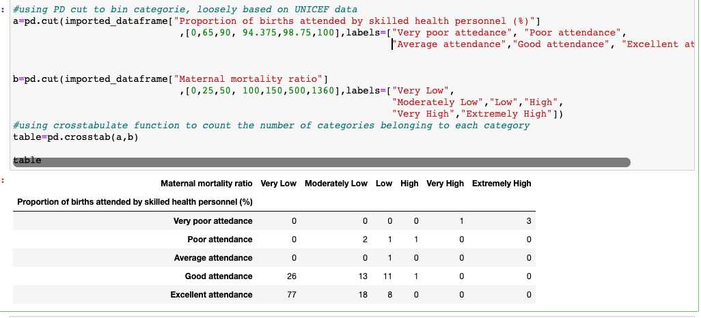

Figure 3. Full Code used to produce a cross tabulated table.

#### 2.4.3 Charts Produced

**Chart 1** is a scatterplot that shows the relationship between PBH(%) and the MMR. The chart treated MMR (x axis), and PBH(%) (y axis) as a dependent and independent variables, respectively. 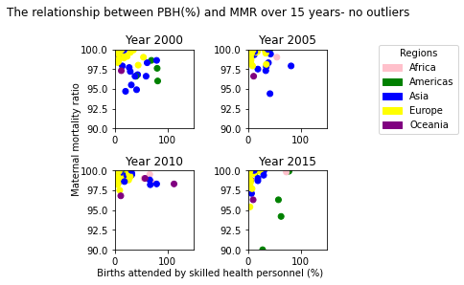

*Figure 4. Figure 5.*  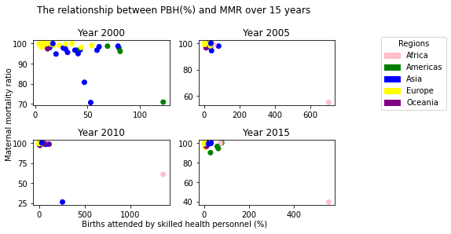

***Figure 4.*** *Scatterplot representing the relationship between PBH(%) and MMR, over 10 years at 4 discrete years (2000, 2005, 2010, 2015).* ***Figure 5.*** *This is figure 4. without outliers.*

**Construction of plots**

The main steps taken to create subplot include using matplotlib to create 4 subset of dataframes, based on years. A dictionary was created with the legend and fed into the .map() function to groupby regions. A manual legend was created using the mpatches library. Then, 4 different scatter plots based on years were creating using the subplot function.

**Code used to produce graph**

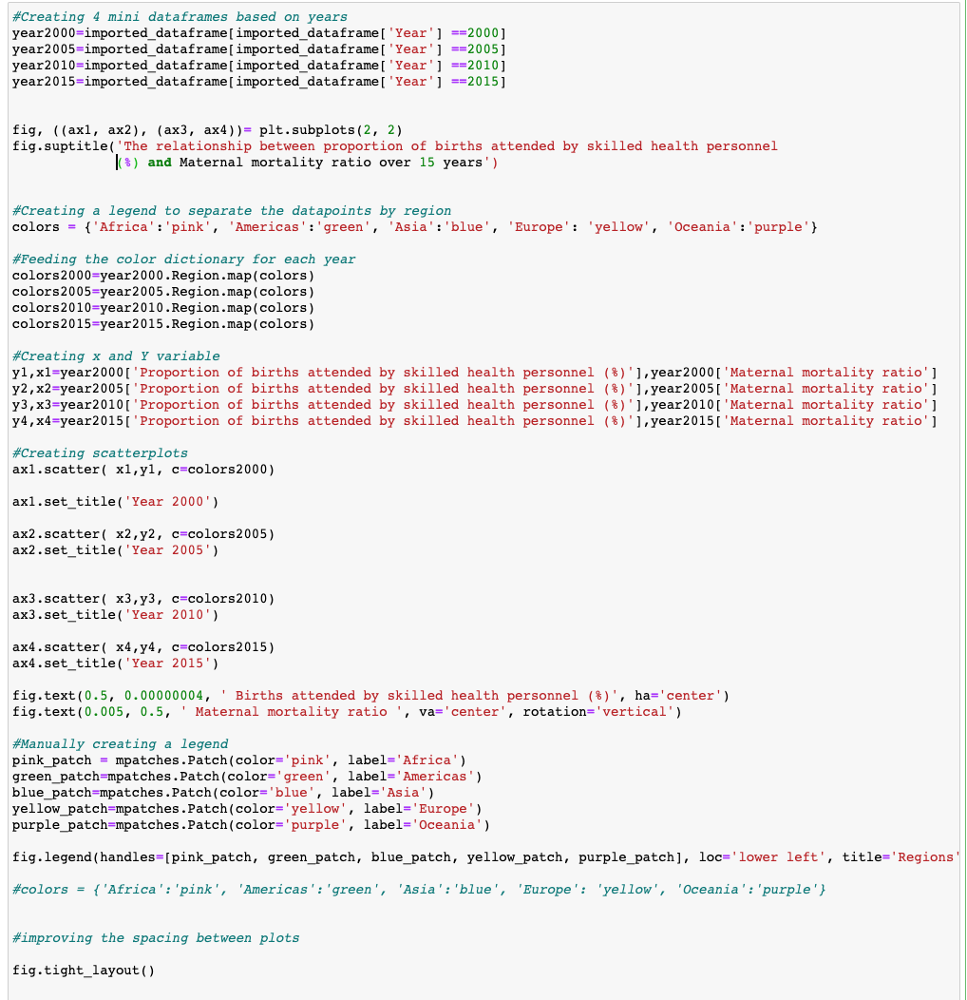

*Figure 6. Snapshot Code used to create 4 subplots. Refer to Appendix C 4.3 for full code.*

Note that the code used to limit the x and y axis was similar except for each subplot, .set_xlim and .set_ylim functions were used. Refer to Appendix C 4.4 but an example of code is produced below:

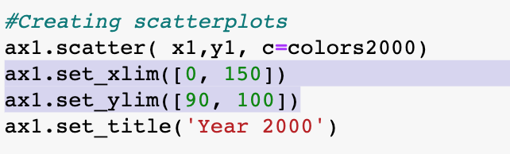

*Figure 7. Snapshot of code added to remove outliers in figure 5 by limiting x and y axis to show a greater distinction between datapoints due to their highly clustering nature.*

**Chart Evaluation**

This chart was constructed to have 4 attributes/ aspects. Chart encoding: **(1)** The colour of the datapoints is grouped by regions, a categorical variable. **(2)** Subplot tool was used to create 4 different miniplots to represent how the datpoints changed over the 4 discrete years. The years were treated as a discrete , quantitative variable in the construction of this plot. **(3)** X position is based on the independent variable PBH(%). The limit of the x axis was changed to remove outliers in Figure 5. **(4)** Y position is based on the dependent variable MMR.

The main aim from the construction of the scatterplot was to understand if having more key healthcare personnel would reduce MMR. A scatterplot is appropriate as calculations such as correlation co-efficient data can be completed to test the strength of this linear relationship. However, there may be hidden confounding variables within this relationship and hence the data was grouped by years and region (represented by **legend)** to understand their potential impacts on MMR. The 4 subplots can signify trends across later years where improved healthcare innovation over time could contribute to the reduction of MMR without an increase in PBH(%), and could test if regions (represented by different colours) with differing incomes and healthcare systems have a stronger impact on MMR than PBH, using regression testing. Scatterplots can effectively highlight outliers, representing the inequalities present within different regions (greater the variation in points, greater inequalities in countries within regions).

One of the limitation of this datapoint is that if more datapoints were added, the highly clustered data set may not provide a distinctive visual representation of how the relationship between MMR and PBH(%) change by region. However, interactive libraries such as ‘Plotly’ could be used to analyse each region independently.

**Chart 2** 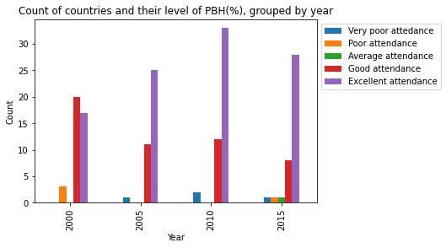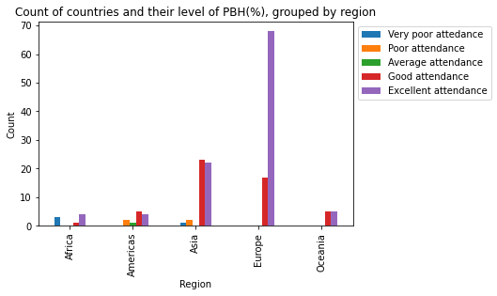

| *Figure 8. Bar chart to count countries and their level of PBH(%), grouped by region* | *Figure 9. Bar chart to count countries and their level of PBH(%), grouped by regi* |
| --- | --- |

**Code used to produce data:**

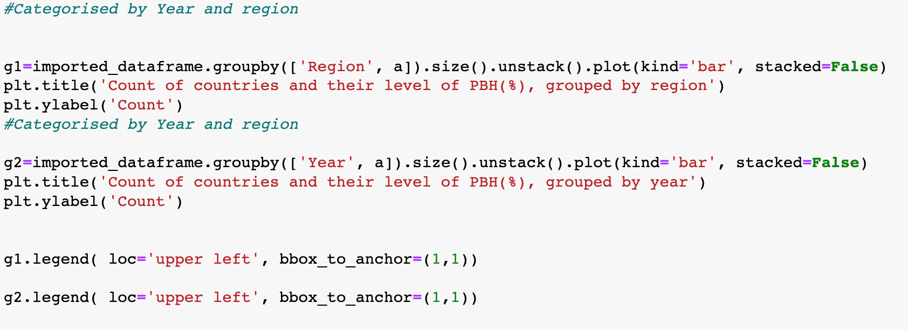

*Figure 10. Code used to produce barcharts, grouped by region and year.*

Main functions used include groupby and plot functions to create a barchart with different types of categorical data (year, region, PBH), using the cross tabulated figures used to develop table 5.

Barchart was chosen to address the limitations of the scatterplot and understand how PBH(%) changed with region and year, and help quantify PBH(%) more easily using the count variable in Y axis. 3 attributes were considered for both graphs. **(1).** The Y-position/ Y-axis represents the count of countries **(2).** The X positions represent region/ year for Figure X1 and Figure X2 respectively. **(3).** The legend represents the **binning of the quantitative variable PBH(%) into ordinal categorical data, (represented by the legend)** based on the levels discussed in the grouped aggregate summary section.

The barcharts can be used in tandem with the scatterplots to better understand the relationship between the PBH(%) and MMR. It is considered that grouping PBH(%) in multiple levels, **represented by the different colours using the legend**, allows a reader to understand distinction between datapoints and reduces issues with tight clustering.. For example, whilst a viewer can see that Europe (yellow points) has had a better PBH(%) vs MMR relationship in the scatterplots, they can more **accurately** quantify this data using Figure 8. Similarly, whilst a user can see that MMR relationship improved, indicated by tighter clustering from years 2000 to 2015 in the 4 sub-scatterplots, they can quantify how much this change was due to the changing levels of PBH(%) over the years. As such, this data would be **extremely effective as more data is added- considering the low standard deviation of datasets (I.e tight clusters in scatterplots)**, changes can be better quantified using the figures in the “Count”/ Y-axis.

However, figure X1 is limited as it may not be truly directly comparable to the scatterplot as it is an overall count over the 4 years whilst the figures 4 and 5 scatterplots have been sub-sectioned by the years. For example, a viewer may attest the pattern in Figure 8 to one subplot/ year. However, these views can be corrected with a supplementary analysis of Figure 9 to see how PBH(%) change over the years.

# Part B

## 3. Conclusion

As stated above, the relationship between MMR and PBH, Physicians, Nurses, Pharmacist is highly important to healthcare decision-makers from different countries, regions and multinational organisations, involved in effective obstetrician care and women’s health.

### 3.1 Subsection 1

520644847 was responsible for the completion of this section.

**Issue :** Student 520644847 investigated the relationship between MMR and Pharmacist worker density and found no dispute to the underlying hypothesis. There seemed to be an inverse correlation between Pharmacist worker density and Maternal mortality ratio, which our tables and figures supported.

**Insight :** The inverse correlation between the two features being investigated (which can be seen in figure 8) may be explained by a variety of reasons. This could be that poor health infrastructure leads to less pharmacists and less adequate care for birth givers, or it could also indicate that in areas with more health workers, the more readily available they are to aid with birth giving. Additionally, this is also supported by the tables produced in section 2.1.2, and in particular figures 2 and 3, where it can be seen that regions with the lowest Pharmacist worker density subsequently have the highest Maternal mortality ratios. A better illustration can be found in the chart produced in section 2.1.3, figure 4.

The same is true for the rest of the relationships analysed/charts produced. In tables 2.2.2 figure 3 and 2.3.2 figure 4, we can see the same inverse relationship between health worker density (Physician and Midwife) and maternal mortality ratio explored in 2.1.2 figures 2 and 3, as well as the same for graphs 2.2.3 figure 4 and 2.3.3 figure 5. This backs up what we have already discovered in section 2.1.

A point of interest is in the relationship between Maternal mortality ratio and Proportion of births attended by skilled health personnel (%), where we can see a downwards trend between the two features in 2.4.3 figure 5, yet there are not enough points to see the full extent of this trend (i.e there was not enough data for lower proportion of births attended by skilled health personnel (%)). The data used for this can be explained by 2.4.2 tables 2 and 3, and this has also been noted in the limitations section.

### 3.2 Subsection 2

**Issue**

520392823 analysed the relationship between Maternal Mortality Ratio and Physician density and found a weak negative correlation between the two variables. A strong negative correlation was expected, as physicians are general doctors that play an important role in pregnancy and the 9 month period.

**Insight**

​​The expectation is that the more physicians there are, the lesser the maternal mortality ratio would be. This is as physicians are are general doctors that play a variety of roles in relation to pregnancy.

In figure 4 graph 3 under section 2.2.3 we can see a general weak negative correlation between the two variables. This is shown by the dark blue line in the third graph in the subplot which has a slightly negative gradient (goes downward) from left to right. This weak negative correlation tells us that the higher the density of physicians, the lower the maternal mortality ratio will be to a small extent. The weakness of this trend shows when looking at Figure 3 under section 2.2.3 where we see Oceania had the same MMR and Physician density. However, for Europe, Asia and the Americas this trend does seem to be in effect. This can be seen when going from Africa to the Americas, Asia, and Europe; The physician density increases and maternal mortality rate decreases. However, a limitation of this is that physician density does not mean people have access to the physicians. This is as there may be other factors which may limit access to physicians and other pregnancy related personnel.

Hence, we can conclude that while there is a weak negative relationship, density of Physicians is not the key factor in determining maternal mortality ratio.

### 3.3 Subsection 3

**Issue:** 520617829 analysed the relationship between MMR and nurse/midwife density. There is a weak negative correlation between the two attributes, the negative correlation was expected to be more pronounced and uniform for different regions and different years but that does not seem to be the case. There may be other factors in Africa

**Insight:** The most important conclusions drawn from the tables and charts as stated above will be reiterated and discussed in this section:

The sum of maternal mortality ratio and sum of nurses and midwives for each region, Please refer to section 2.3.2 Figure:.4 and 5 for tables that do not have the relationship that would be expected. For example: (a) Americas have a lower density of nurses and midwives than Asia but Asia has a higher maternal mortality ratio as compared to Americas.This could be because of the availability of better healthcare infrastructure and education but there seem to be many confounders.Further, We see that increasing the density of nurses and midwives in an area does not necessarily imply that we get a lower maternal mortality ratio.

Secondly, the weak negative correlation between the graphs for different years and regions does not seem to follow a uniform trend for all regions , See chart in 2.3.3 Figure 5. The subplots would have had different lines of best fit for different years.

Thirdly, the chart overall seems to have a weak negative correlation between the two attributes for each region and year despite the minor unexpected characteristics of the two attributes; The negative correlation seems to be the same for all the columns with healthcare workers involved, see section 2.2 Fig 3. and 2.1 Figure 8.

### 3.4 Subsection 4

**Issue:** 500545654 completed this section to analyse if PBH(%) impacts maternal health during childbirth. As stated above, it is hypothesised that there is a direct relationship between PBH(%) and MMR but PBH(%) is also correlated with the actual levels of physicians, nurses, midwifes available.

**Insight:** Following Section 2.4 Table 5, it can be seen that higher the attendance, lower the mortality rate. However, there were some cases where ‘Excellent attendance’ had varying levels of mortality rates from moderately low (18 cases) to low (8 cases), suggesting that other variables may impact MMR rate (i.e. the skill and training level of healthcare professions are etc.).

The tightening of clusters/datapoints from 2000 to 2010 as shown by section 2.4 Figure 4, highlights that over time, the MMR improved with PBH(%). This analysis is confirmed by Section 2.4. Table 2, where the mean and median PBH(%) is increasing over time, and by figure 9 shows that there was in increase in ‘Excellent Attendance” for the same years. However, this change can perhaps be attested to better technological advancements in maternal healthcare as opposed to the level of PBH(%).

Healthcare inequality within a region, and amongst different regions is highlighted by above graphs. There is a large difference between the median (71.5) and mean (367.3) MMR in Africa, shown by Table 2, indicating varying differences in obstretetric health care within countries in this region compared to other regions- further evidenced by having the greatest disparity between mean and median PBH(%) in Africa. For multi-national healthcare planners, global maternal healthcare inequality can be reduced by decreasing the gap between the median and mean PBH(%) as represented by Section 2.4 Table 4 .

In general, a greater PBH is impacted by the number of other healthcare staffs available. Evidently, the PBH(%) improvement with MMR coincided with with tightening of clusters in physician (Section 2.2 Chart 1) and nursing (Section 2.3 Chart 1) density over time. The European region that had the greatest nursing and physician density as seen by section 2.3 Table 2, indicated a greater level of PBH(%) and the lowest level of MMR. However, a greater availability of healthcare staff doesn’t indicate their utility within the obstetrics unit. Evidently, in section 2.2 Table 2, Americas and Asia had similar physician density at 17.8, and 23.2 but widely different PBH(%).

## 4. Discussion and Limitations

**Limitations:** Whilst the accuracy of data**-**number one consideration in effective plot creation (Poon, 2022)**-** was ensured by obtaining it from a reputable source (WHO, 2022), the plots created may be flawed. Inherently, scatterplots are difficult to interpret with distortion in size of points, complicating the interpretation of x/y values. A line of best fit could have provided a more reliable analysis but attempts were taken to resolve issue through creation of barcharts where x/y values could be interpreted better. The outliers that were removed, would have made the negative correlation more pronounced but that graph gets hard for the reader to interpret and looks congested.

Further, there were not enough data points for the lower categories PBH(%), which created data that was tightly clustered, reducing the visibility of the points in the scatterplots. If there were more points between 0-90% of births attended by skilled health personnel, this would paint a better picture on the graph and is thus a limitation in our dataset.

It was initially hypothesised that there was an inverse relationship with MMR and healthcare density/ PBH(%). However, the scatterplots produced by all 4 members indicated that the linearity between the two variables isn’t as strong and that other variables like technological advancement and research and development status of different regions may have impacted results. This analysis could be better proven with a linear regression analysis.

Another point of emphasis is that some subplots created did not have a common y axis scale. This makes it hard to compare one plot to another for the viewer and makes it difficult to see a general trend as the points were ‘crowded’. Perhaps removing outliers or merging the axes scales of the subplots would make this more visible.

An interesting trend we can see is in Africa in Fig 8 under section 2.2.3, all the charts had one datapoint in Africa with high maternal mortality ratio. This tells us that there may be other factors in Africa leading to such a high maternal mortality ratio. To explore this we can look at the other columns for clues. In subsection 2.1.2 figure 2 we can observe that Africa had the lowest pharmacist worker density by region and year. In subsection 2.2.2 figure 3we can observe that Africa had the lowest physician density as well. In subsection 2.3.2 we can observe Africa had the lowest Nurse midwife density as well. Along with this in subsection 2.4.3 chart evaluation, chart 2 we can see Africa had the most very poor attendance along with the lowest good and excellent attendance. This tells us that there are other factors in Africa that point to it being an outlier. As such we can interpret this to mean there is most likely an even weaker correlation in the data if were not to count African data.

## 5. References

World Health Organisation “SDG Target 3.1 Maternal Mortality.” *Www.who.int*, 2022, www.who.int/data/gho/data/themes/topics/sdg-target-3-1-maternal-mortality.

World Health Organisation. “Indicator Metadata Registry Details.” *Www.who.int*, 2022, [www.who.int/data/gho/indicator-metadata-registry/imr-details/25](http://www.who.int/data/gho/indicator-metadata-registry/imr-details/25).

## 

## Appendices

### 4. 500545654

4.1 Figure used to create Table 2 

**4.1**

**4.2**

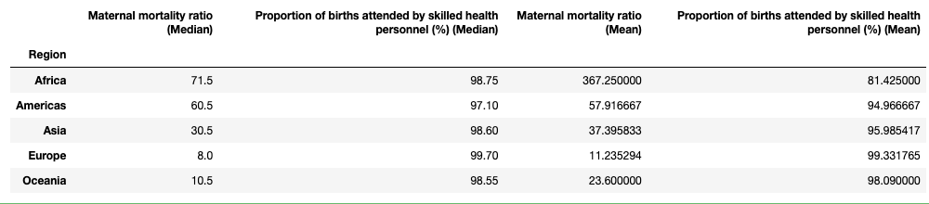

**b.**

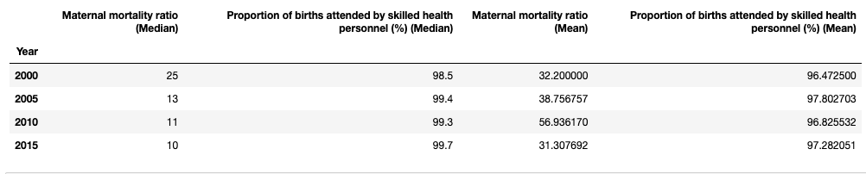

**c.**

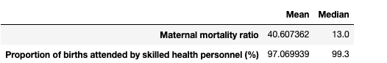

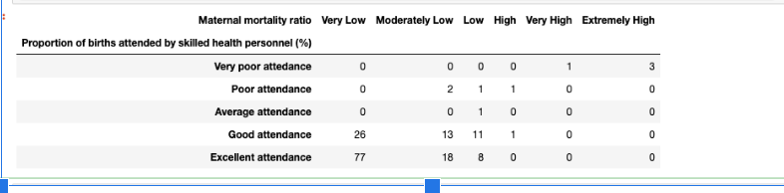

**4.3 - Code used to produce figure 5**

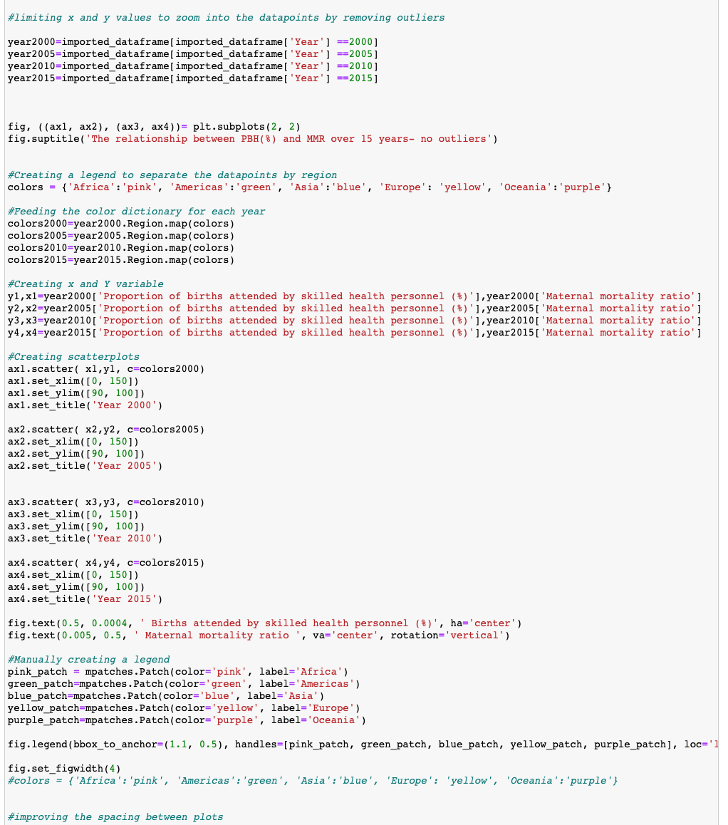

### Appendix A. (520644847)

A.1. Python code used to aggregate Pharmacist worker density by year and region

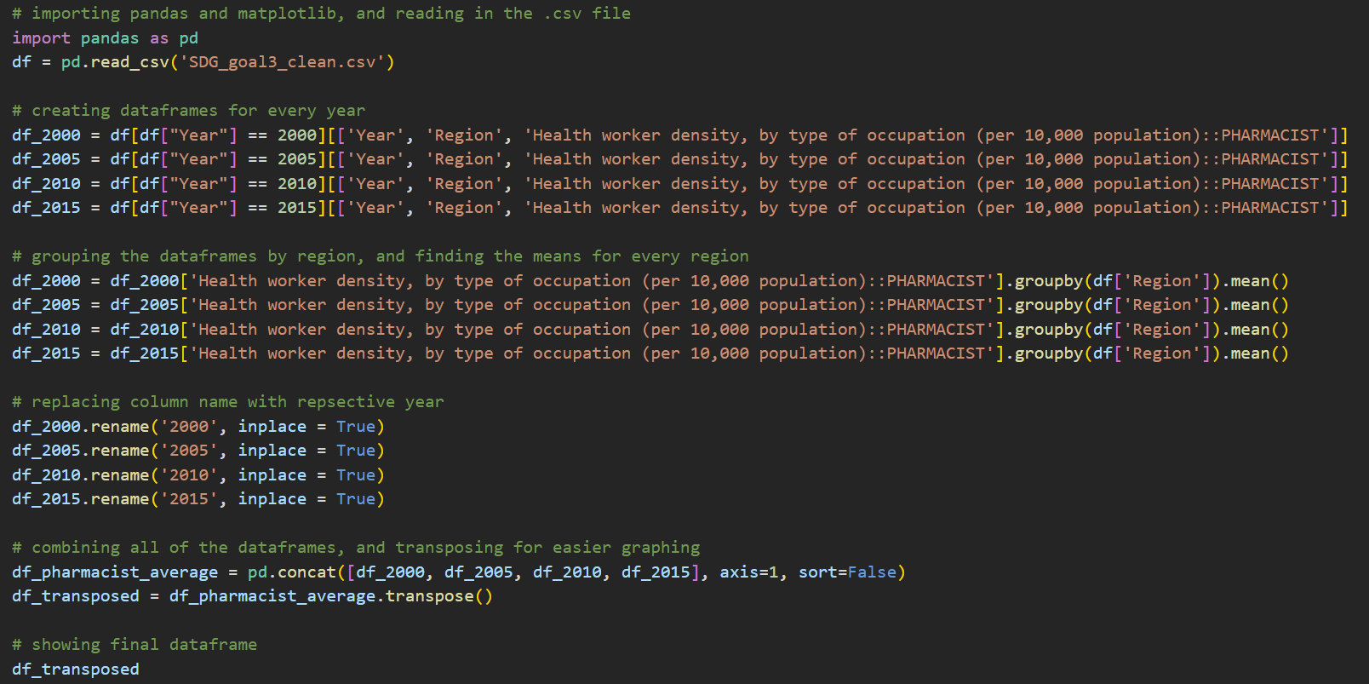

A.2. Python code used to aggregate Maternal mortality ratio by year and region

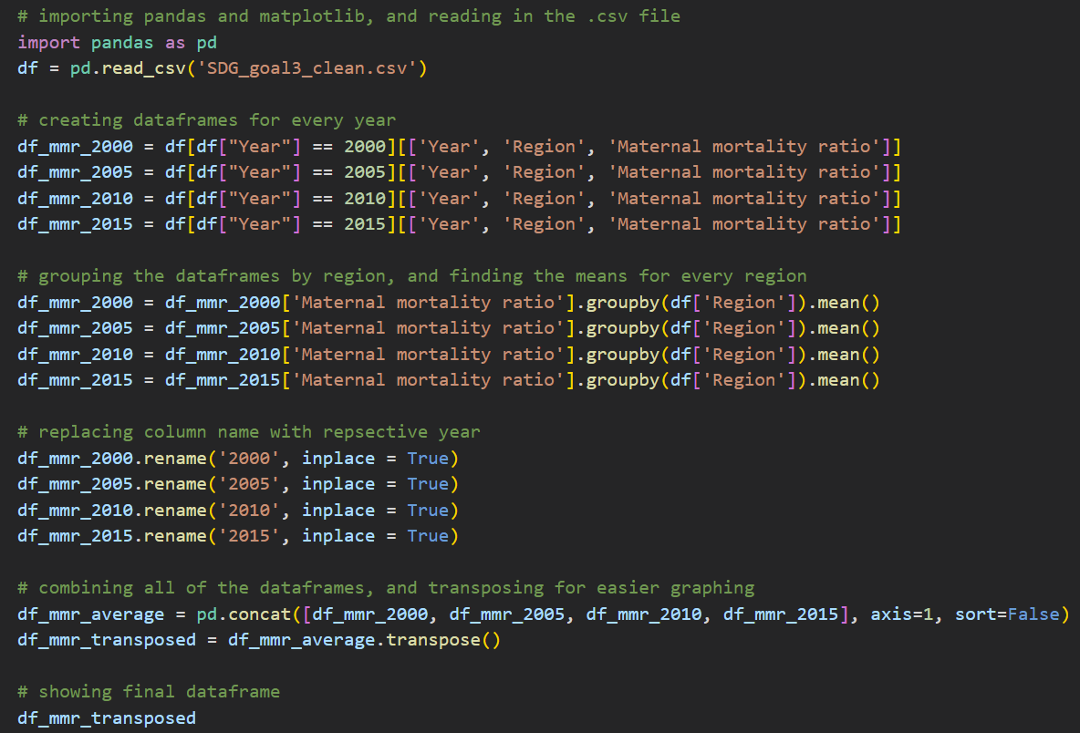

A.3. Python code used to produce the two aggregate summary bar plots

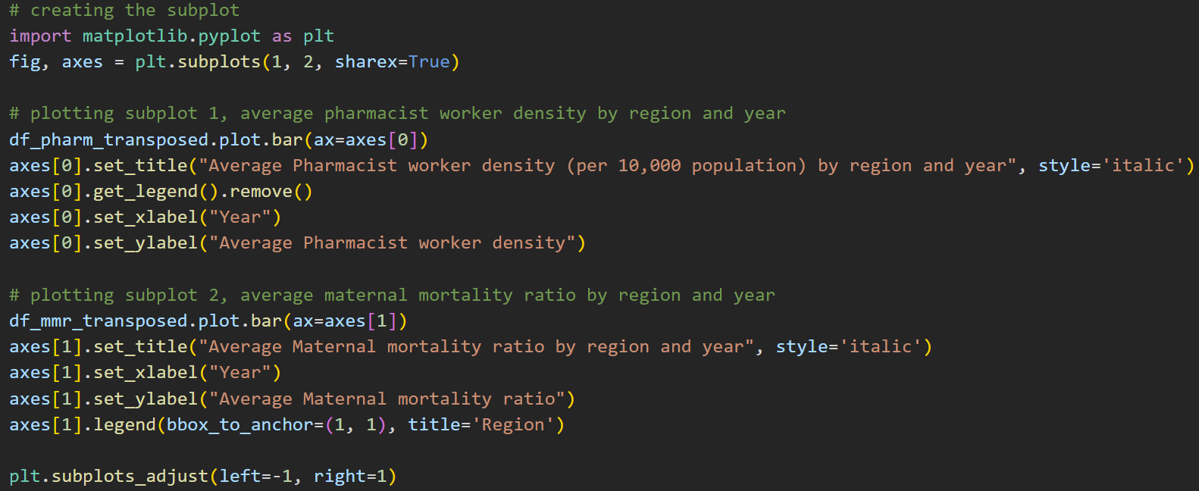

A.4. Python code used to create scatter plots of Pharmacist worker density against Maternal mortality ratio

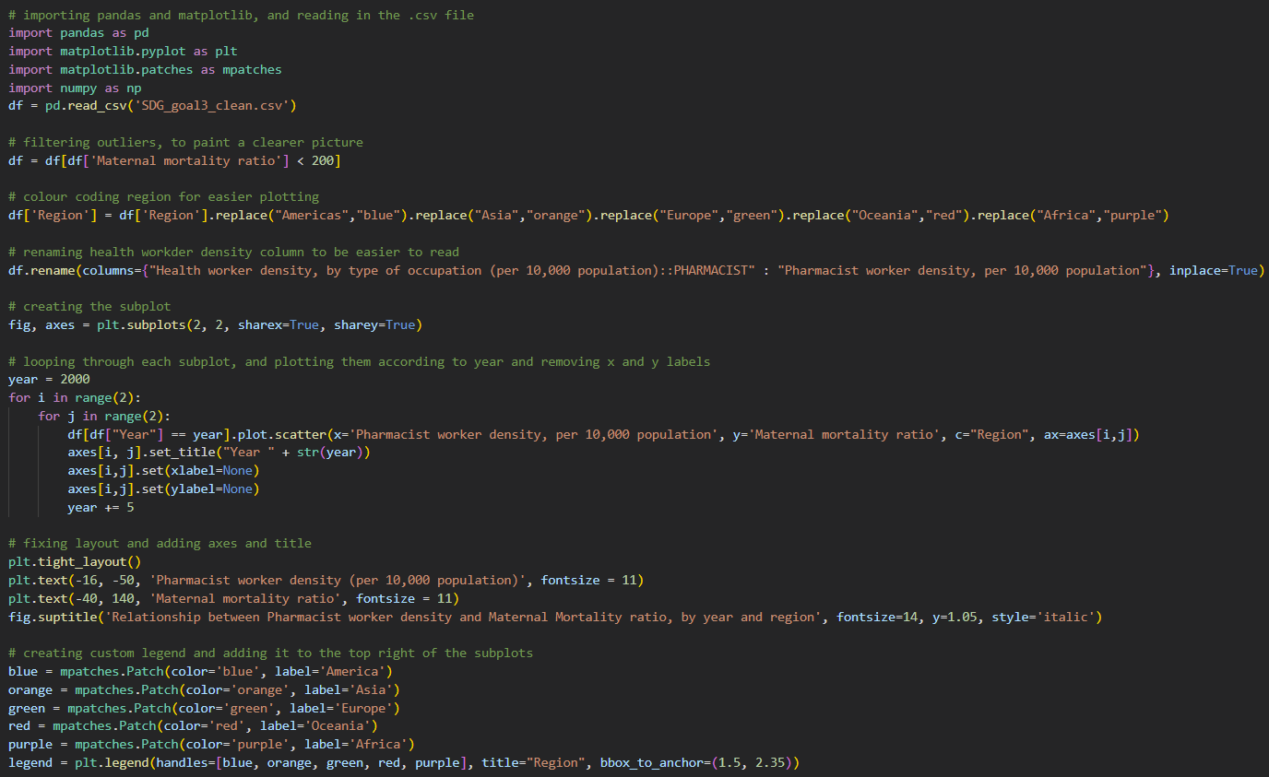

on

### Appendix B. (520617829)

B.1 Leftover code used to produce Figure 5 in 2.3.3

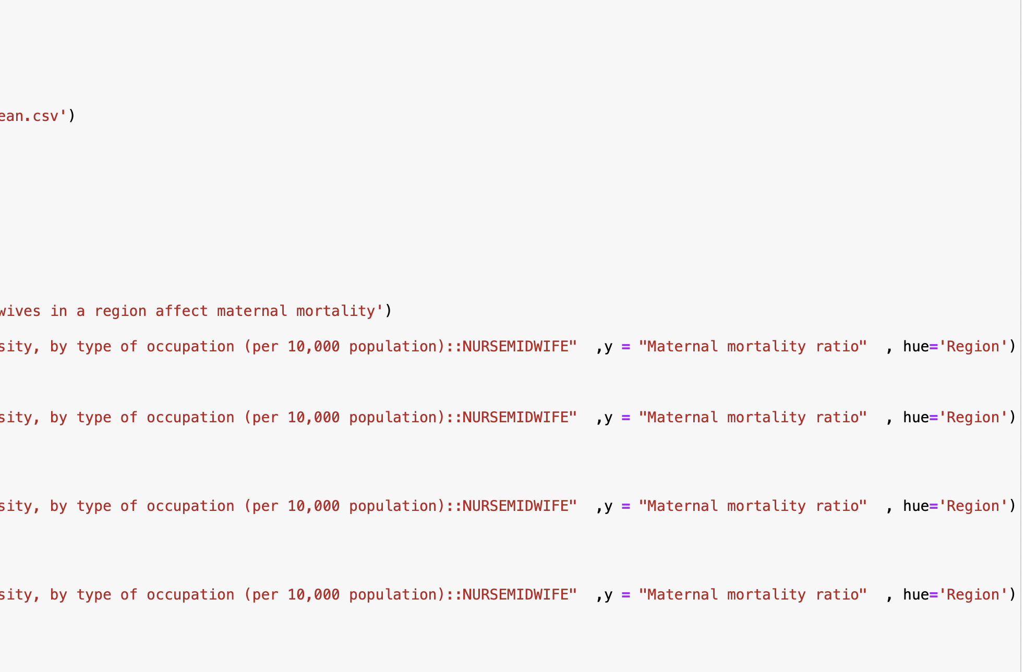

B.2 Figure 5 with outliers but without being separated by year i.e it contains three attributes:Maternal mortality, region and nurse midwife density

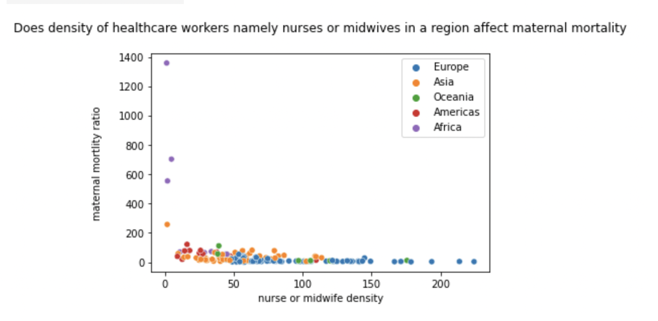

B.3 Full code for Figure 5 in 2.3.3

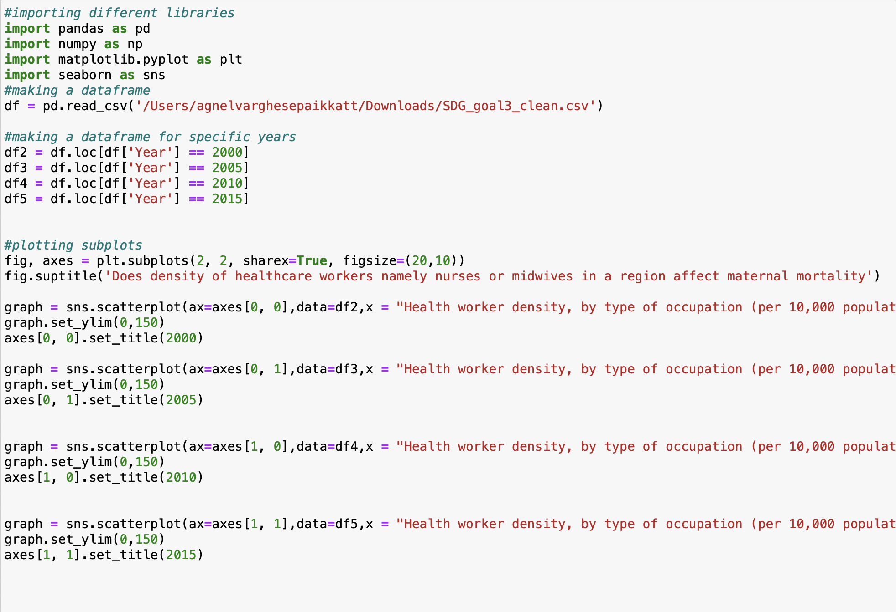

### Appendix C. (500545654)

**4.1 Figure used to create Table 2**



**4.1**

**4.2**



**b.**



**c.**



**d. Output**



**4.3 - Code used to produce figure 4 (Subplot without outliers)**

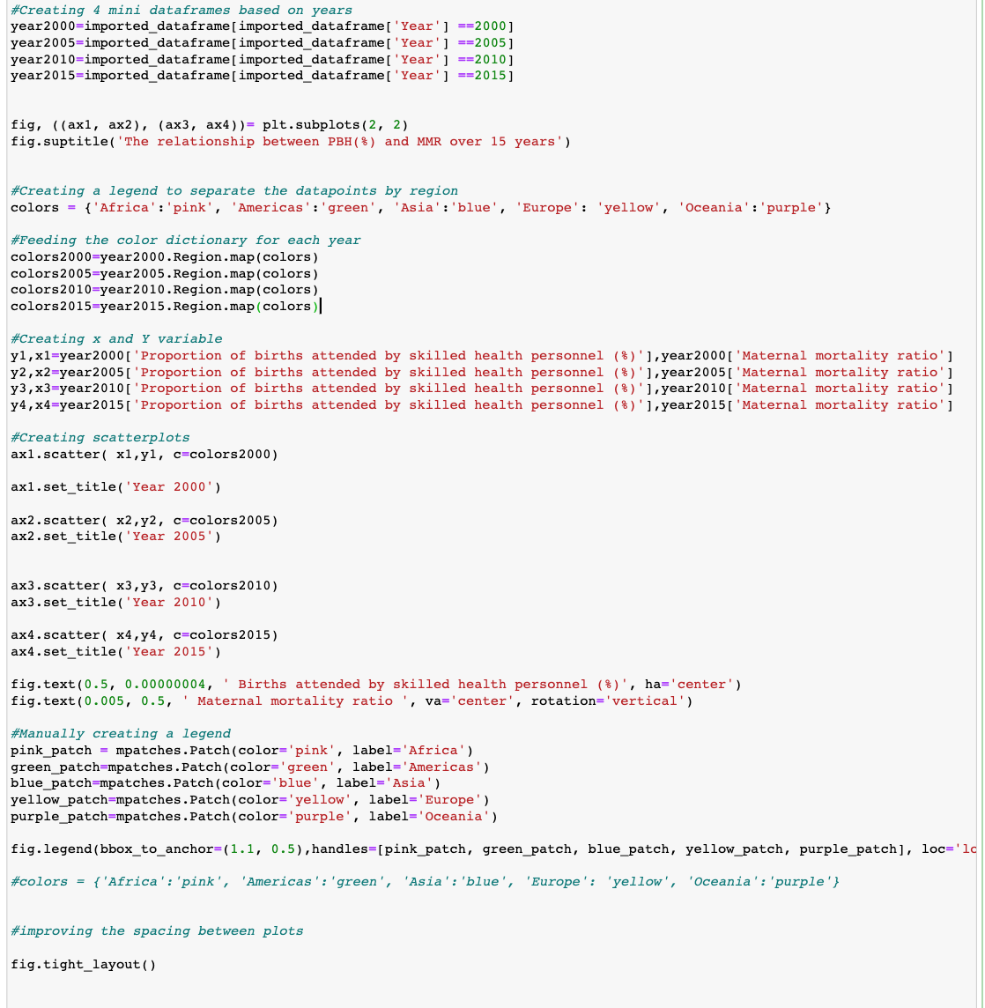

**4.4 - Code used to produce figure 5 (Subplot without outliers)**

